1. Create view that joins the tables Customers, Orders and Order_Details and name it CustOrderItems.

CREATE VIEW CustOrderItems AS

SELECT c.CustFirstName, c.CustLastName, o.OrderNumber, o.OrderDate, o.ShipDate, od.QuantityOrdered * od.QuotedPrice as ItemTotal

FROM Customers c

JOIN Orders o

ON c.CustomerID = o.CustomerID

JOIN Order_Details od

ON o.OrderNumber = od.OrderNumber;

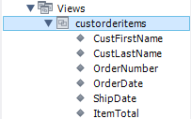

1. Show the orders with customer numbers and order totals in this form.

SELECT CustFirstName,CustLastName,OrderNumber,OrderDate,ShipDate, SUM(Itemootal) as OrderTotal

FROM CustOrderItems

GROUP BY OrderNumber;

